Instructions for Information Privacy and Security Training Requirements

Access the CITI Program Training Website
Log in with Your SDSU ID (Single Sign-On)

For new and existing users: Sign in through the option, in which it will ask to sign on through an existing institution. Type in San Diego State University and a drop-down option will appear.

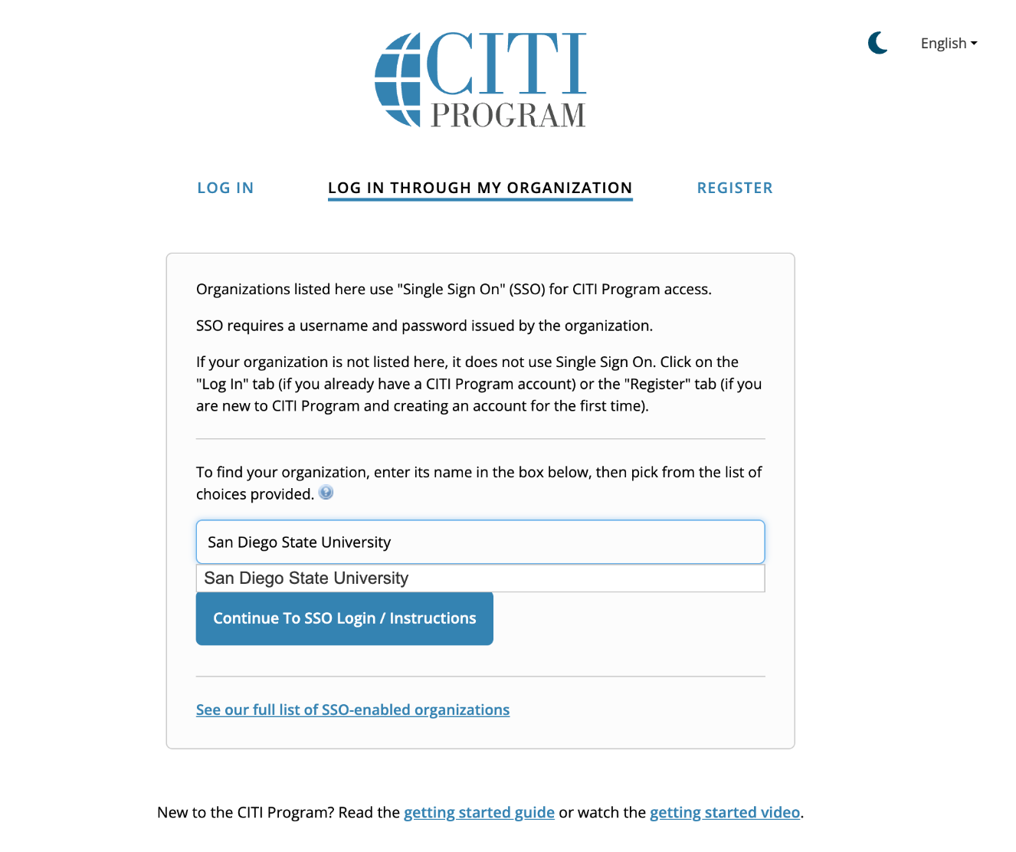

Once selecting San Diego State, you will be redirected to the San Diego State University Single Sign On. Log in with your SDSU credentials (email address). Once entering your SDSU email and password DUO Authentication will be prompted.
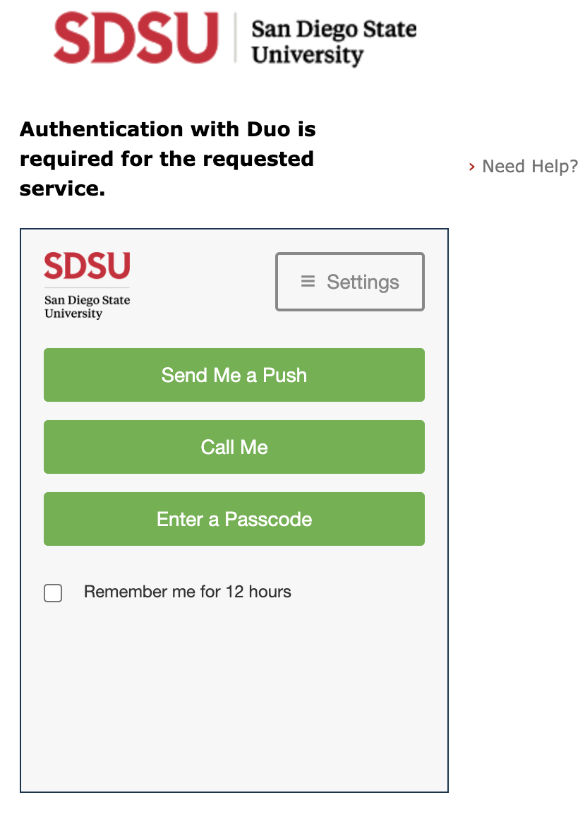
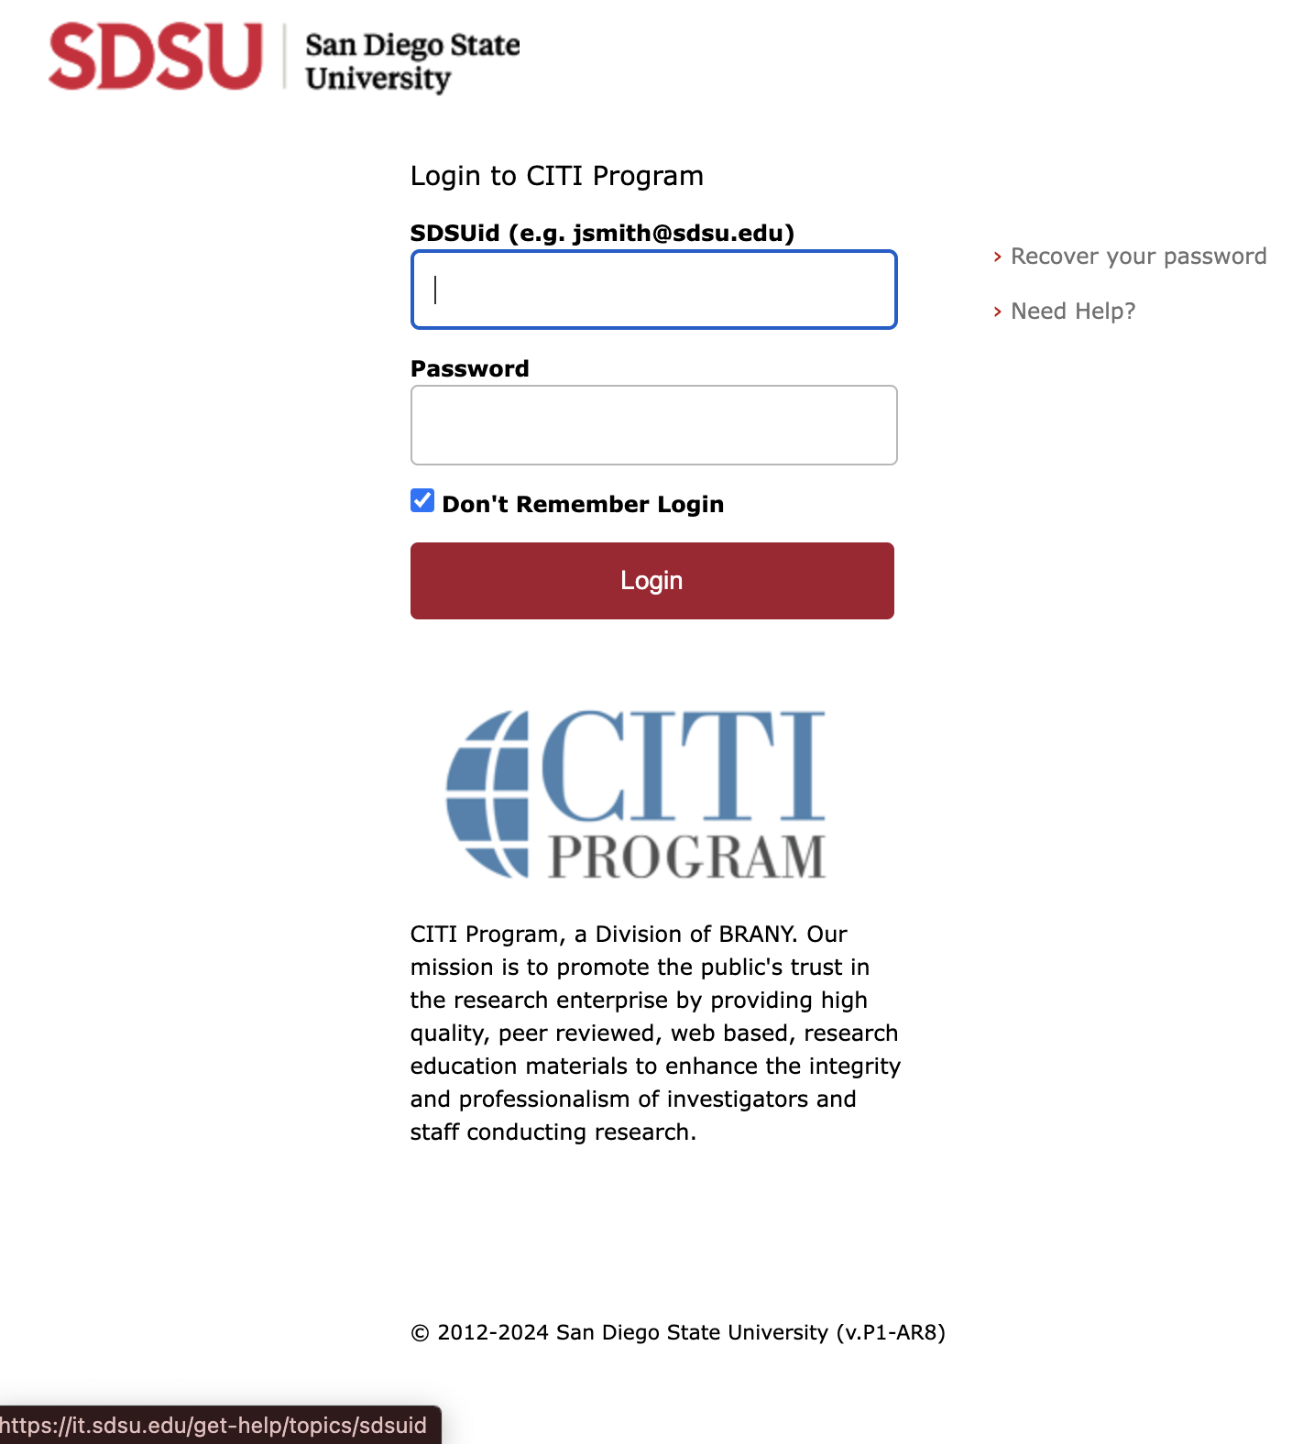

Once Logging in. CITI will ask if you would like to associate your account with the sign on, or if you have not created an account before, CITI will allow you to do so.
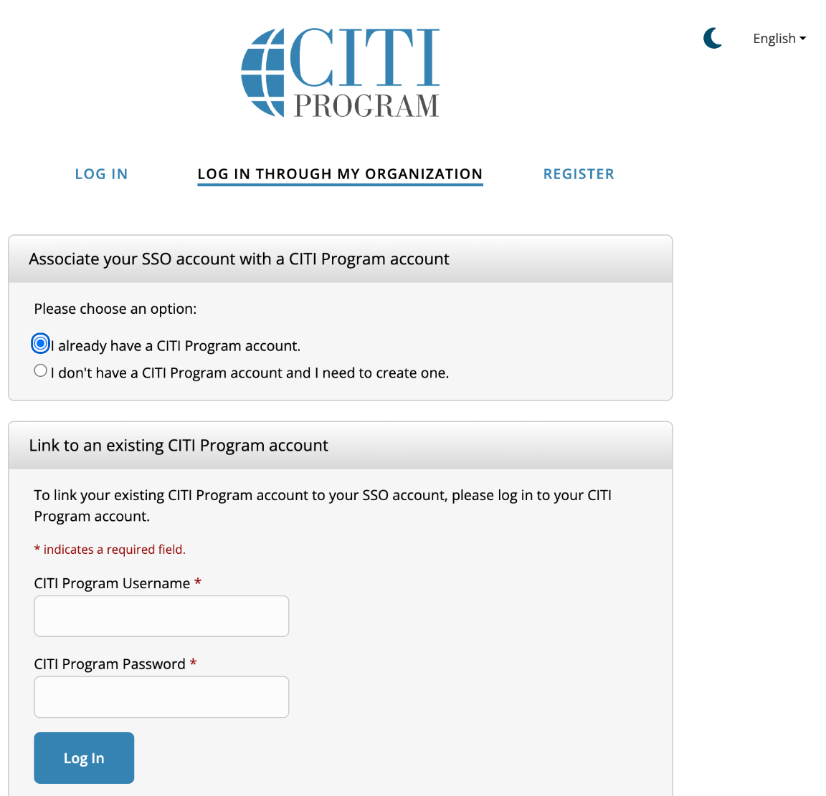
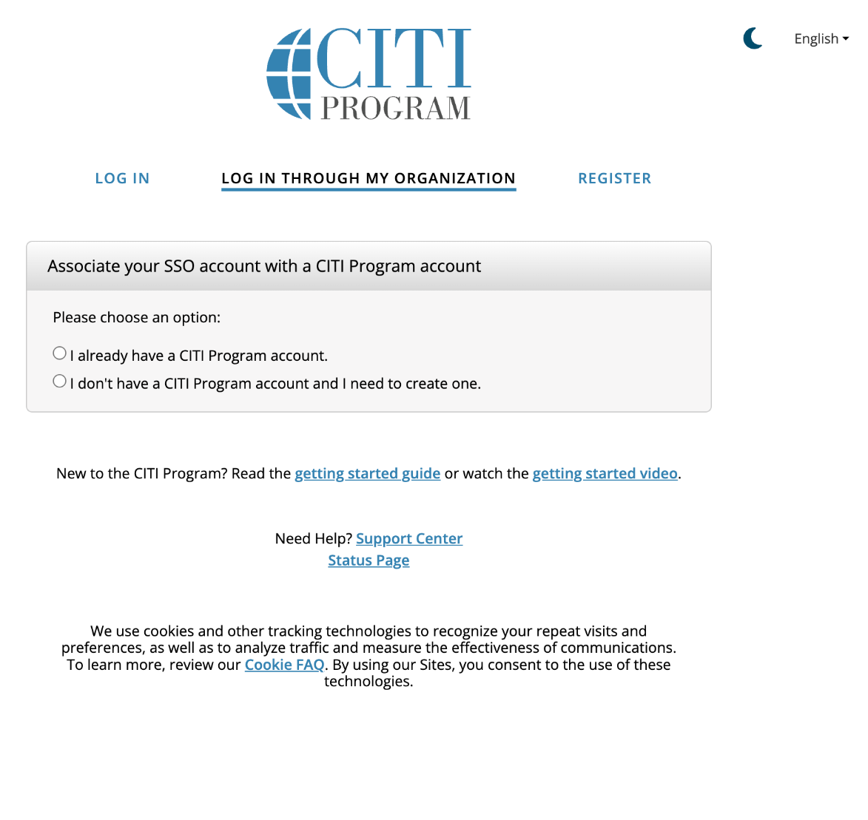

For Both New and Existing (previously registered) users:
Select: “ Add a course”. This will take you to a questionnaire. The curriculum in which you will be enrolled will be based on your responses. Your responses must be based on the type of research activity you are or will be engaged in at SDSU. Please read the introductory instructions for each question carefully. You will be assigned the required training based on your responses and the type of activity you are engaged in at SDSU.
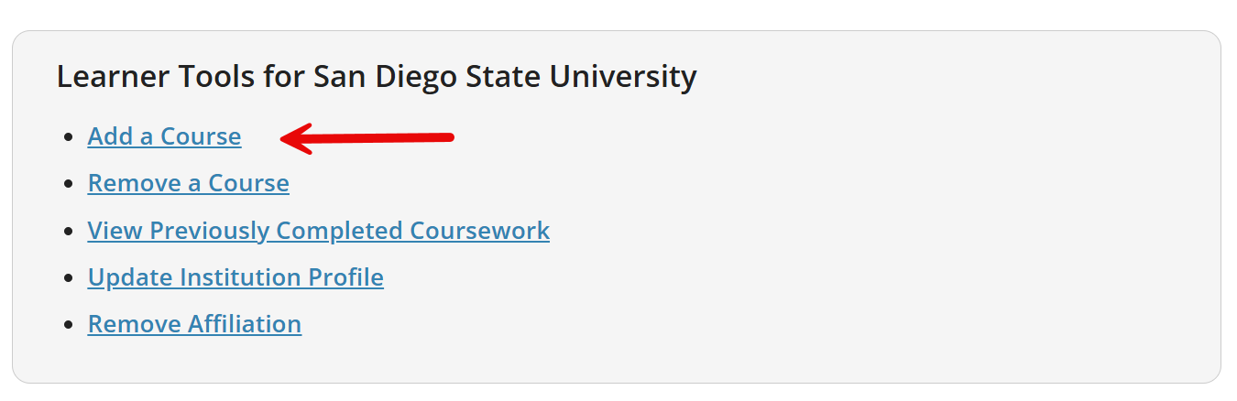
Most modules contain a quiz. A minimum aggregate score of 80% is required to pass the courses. You do not need to complete all the modules in one session. There are several optional modules available for additional information on areas of specific interest depending on the focus of your research.
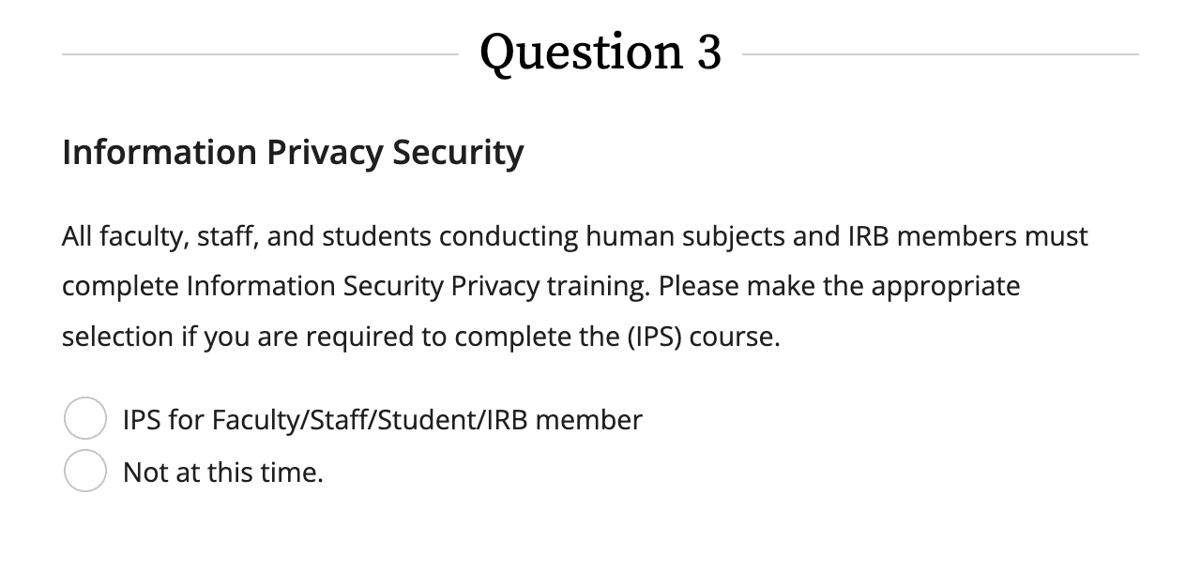
All users: Scroll down to Question 3, Information Privacy Security. Select the “IPS for Faculty/Staff/Student/IRB Member” course. This course meets the training requirements for NIST 800-171 and NIH Controlled-Access Genomic Data.

