Request UCSD AD Credential

If you do not have a UCSD AD, please obtain a UCSD AD credential prior to requesting an ePRMC account. The UCSD AD credential would allow you to access vpn.ucsd.edu. The credential request can be submitted to PRMC Office at prmc@ucsd.edu and CC John Diaz jcdiaz@ucsd.edu on the request. Here is an example of the request:
Subject: Active AD Object for ePRMC Account
Text: Good Afternoon, may I please obtain AD accounts for the following study staff at SDSU:
Full name:
Email address:
Position/Title:
Office Phone Number:
Office Address:
The staff will need account for 5 years.
Please let me know if you have any questions.
Thank you in advance for your help.

Request ePRMC Account
(Go through https://vpn.ucsd.edu to open ePRMC website https://oncline.ucsd.edu/PRMC/Request1.asp)
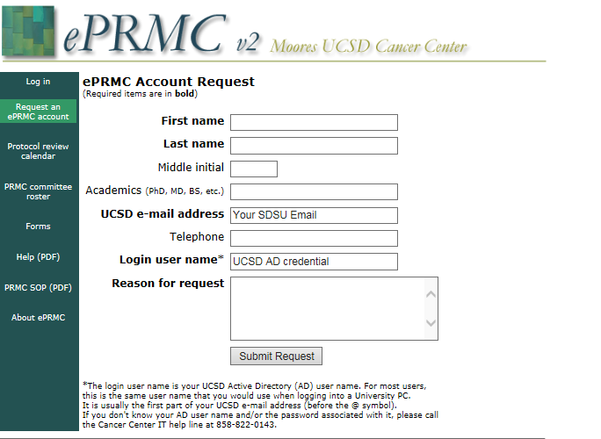
Note: login password is your UCSD AD password

