**Instructions for Collaborative Institutional Training Initiative (CITI) program Access and Training Requirements**

Access the CITI program web page: <https://www.citiprogram.org/>

**A New CITI User**This path is for someone who has never accessed the CITI site before. Use the “Create an account” Register button on the right hand side of the main page. Complete the registration questionnaire with the required information (Note: not all questions will require an answer). Please use your SDSU email address as your preferred email address. You will receive confirmation that your account has been set up via email.

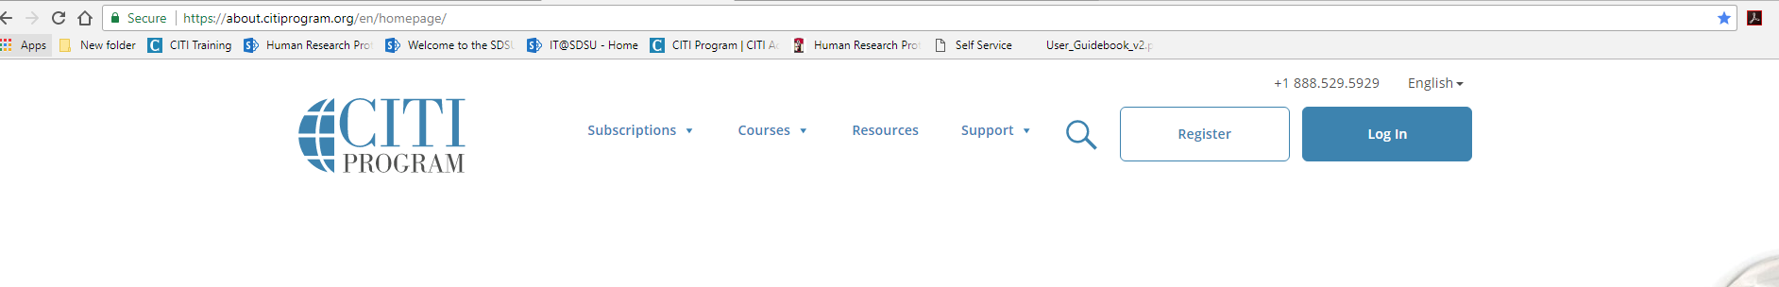

After creating your account, access the CITI program web page and enter your username and password and click login to be taken to the CITI Main Menu.

Choose: affiliate with another institution and select San Diego State University.

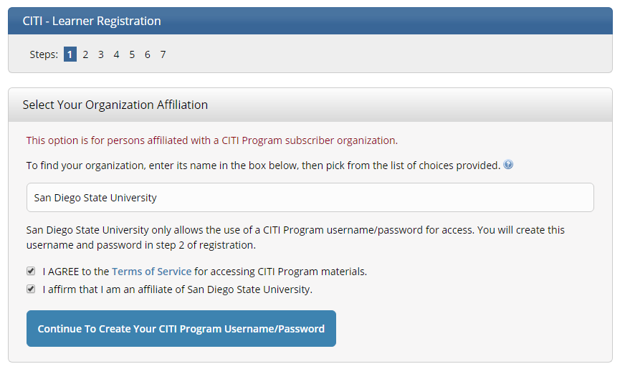

**An Existing CITI User**

This path is for someone who has previously registered and affiliated with another institution. Access the CITI program webpage via the link above. Login by entering your username and password. For this section choose “affiliate with another institution” and choose San Diego State from the dropdown menu.

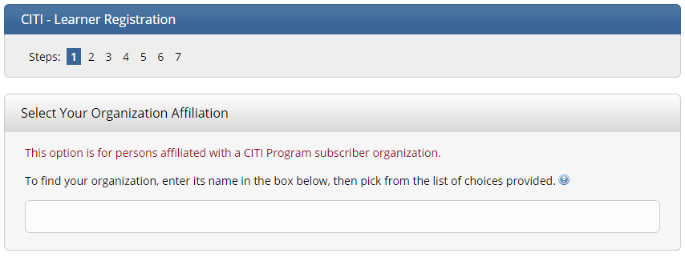

For Both New and Existing (previously registered) users:

Select: “ Add a course or update Learner Groups”. This will take you to a questionnaire. The curriculum in which you will be enrolled will be based on your responses. Your responses must be based on the type of research activity you are or will be engaged in at SDSU. Please read the introductory instructions for each question carefully. You will be assigned the required training based on your responses and the type of activity you are engaged in at SDSU.

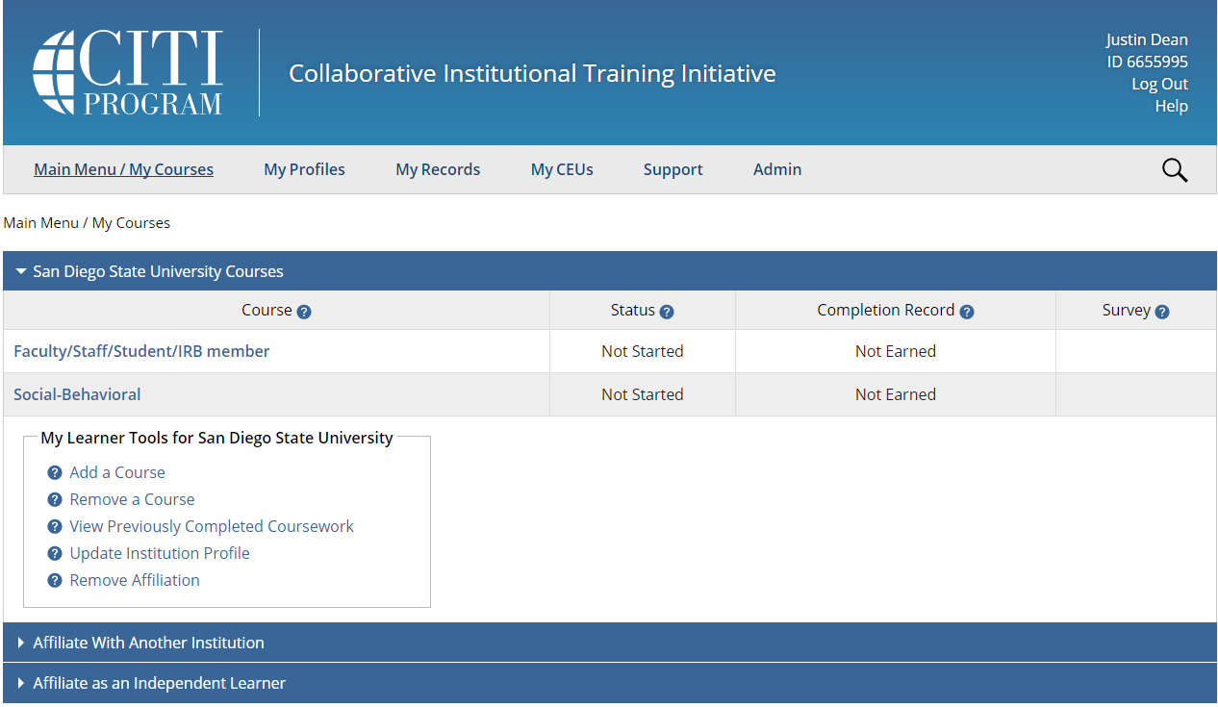

Next choose: Add a Course or Update Learner Groups. This will take you to a series of questions and assign the required training based on the type of activity you are engaged in at SDSU. Please review the training requirements below before selecting learner groups.

Human Subjects Research (More than 1 learner group may apply)

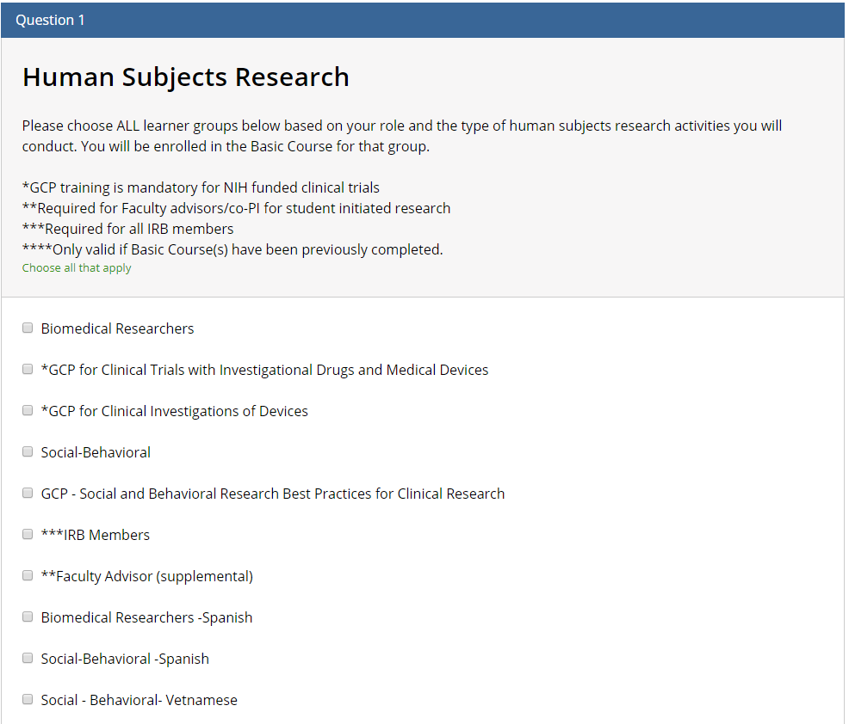

Faculty, Staff and Students that conduct human subjects’ research must be appropriately trained in the protection of human subjects. SDSU uses the CITI web-based courses to satisfy this requirement. Initial and continuing education (every 3 years) are required as explained below. The training is separated into learner groups (Biomedical or Social Behavioral and you should choose the group(s) those that closely match the research activities and other roles and responsibilities (Faculty Advisor, IRB Member) that you fulfill.

Human Subjects Research Learner Groups:

* Biomedical- Choose this group if your research involves clinical trials which are phased studies using human volunteers, designed to answer safety and efficacy questions about biologics, devices, pharmaceuticals, new therapies or new ways of using known treatments.
* Social Behavioral-Choose this group if your research applies the behavioral and social sciences to the study of people’s responses to certain stimuli (internal and external). Academic disciplines that conduct such research are: sociology, psychology, anthropology, economics, political science and history.
* IRB Member-Choose this group if you are a member of the IRB either, permanent or alternate.
* Faculty Advisor-Choose this group if you have signed a Faculty Assurance form indicating that you are a Co-PI and Faculty Advisor on a Student Investigator’s project.
* Choose GCP for clinical trials research.

Most modules contain a quiz. A minimum aggregate score of 80% is required to pass the courses. You do not need to complete all of the modules in one session. There are several optional modules available for additional information on areas of specific interest depending on the focus of your research.

**IRB Administration**

Staff who are involved in IRB administration must be appropriately trained regarding federal regulations, human research protection program management, review and approval of IRB protocols, informed consent process and auditing best practices.

IRB Administration Learner Group:

* All IRB administrators-required training for staff involved in IRB administration.

Most modules contain a quiz. A minimum aggregate score of 80% is required to pass the courses. You do not need to complete all of the modules in one session.

For more specific information on Human Subjects CITI training requirements see: <http://research.sdsu.edu/research_affairs/human_subjects/CITI%20Human%20Subjects%20Training%20Enrollment%20Manual.pdf>

Animal Research (More than 1 learner group may apply)

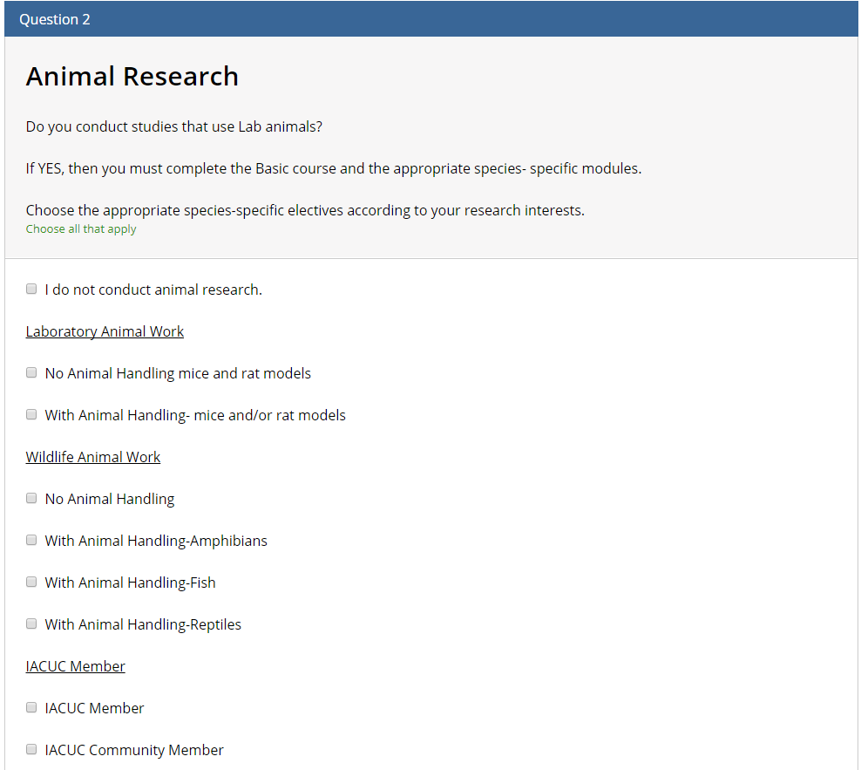

All research personnel conducting research with animals must receive training in the ethical care and use of animals and the regulations, policies and procedures governing animal use in research as well as in the actual procedures that may be performed on animals during the course of the research. SDSU uses the CITI web-based courses to provide basic training in the humane care and use of animals in research and teaching. Initial and continuing education (every 3 years) are required as explained below. Training is separated into learner groups based on the research activities and species used and you should choose the group(s) that closely matches these activities or other responsibilities (IACUC Member and IACUC Community Member) that you perform.  All required online training must be completed before any individual may be listed on or added to an approved IACUC protocol; individuals who fail to complete required training will not be authorized to engage in any activities involving live animals.

Animal Research Learner Groups:

* Laboratory Animal Work-No Animal Handling Mice and Rat Models-Choose this group if you are Faculty, Staff or Student that will oversee, supervise, observe animal research projects that use mice and/or rats but will not directly handle animals.
* Laboratory Animal Work-With Animal Handling Mice and Rat Models -Choose this group if you will handle mice and/or rats in the conduct of your research project.
* Wildlife Animal Work No Animal Handling- Choose this group if you are Faculty, Staff or Student that will oversee, supervise or observe animals in a field research project but not directly handle animals.
* Wildlife Animal Work With Animal Handling Amphibians-Choose this group if you will handle amphibians in the field.
* Wildlife Animal Work With Animal Handling Fish-Choose this group if you will handle fish in the field.
* Wildlife Animal Work With Animal Handling Reptiles-Choose this group if you will handle reptiles in the field.
* IACUC Member-Choose this group if you are a member of the IACUC (including Community Members), either permanent or alternate.
* IACUC Community Member-Choose this group if you are a community representative on the IACUC.

Most modules contain a quiz. The modules do not have to be completed all in one login session. A minimum aggregate score of 80% is required to pass the courses. There are several optional modules available for additional information.

Information Privacy and Security

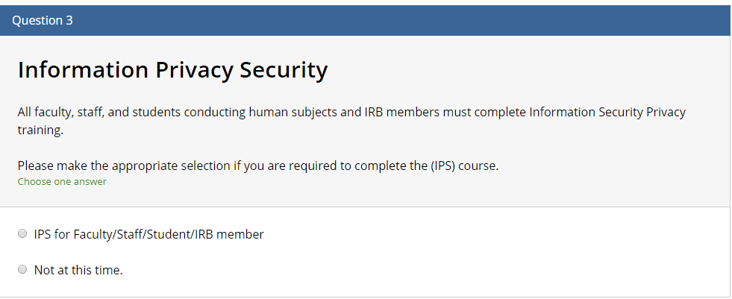

Faculty, Staff and Students that conduct human subjects’ research must be appropriately trained in the basic elements of privacy and confidentiality when using and storing research participant information. SDSU uses the CITI web-based courses to satisfy this requirement. Initial and continuing education (every 3 years) are required.

Information Privacy and Security Learner Group:

* All Faculty, Staff and Students-required training for any persons conducting non-exempt human subjects’ research.

Most modules contain a quiz. The modules do not have to be completed all in one login session. A minimum aggregate score of 80% is required to pass the courses. There are several optional modules available for additional information

Responsible Conduct of Research (More than 1 learner group may apply)

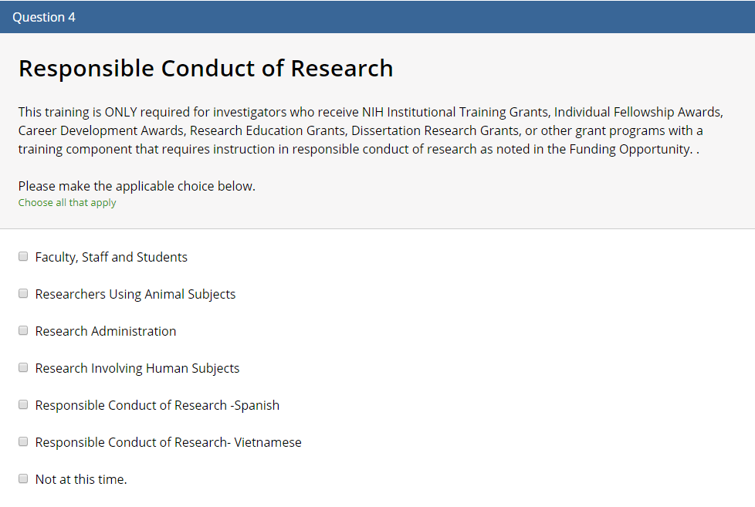

Training in responsible and ethical research practices is an integral part of preparing academic professionals to conduct research. Both the National Institutes of Health (NIH) and the National Science Foundation (NSF) have requirements for training in the Responsible Conduct of Research (RCR). SDSU uses the CITI web-based courses to satisfy one of the elements of this requirement. Initial and continuing education (every 3 years) are required. While the NSF training is only required for undergraduate, graduate students and post-doctoral researchers it is highly recommended that the PI complete the training to begin a dialogue with the students and postdocs on the responsible conduct of research. The training is separated into learner groups and you should choose the group(s) those that closely match the research activities or other responsibilities (Research Administration) that you perform. A notice to persons who will be required to complete this training will be sent by Research Affairs. For all others this training is optional.

Responsible Conduct of Research Learner Groups:

* Faculty, Staff and Students-Choose this group if you have received a notice of required RCR training and you are involved in research in one of the following disciplines; biomedical research (except research with animals), social behavioral research, physical science, humanities, engineering.
* Researchers Using Animal Subjects-Choose this group if you work with animal models in your research.
* Research Involving Human Subjects--Choose this group if you work with human subjects in your research.
* Research Administration-Choose this group if you are involved in the oversight of programs that require RCR training (sponsored research, research affairs, program/project coordinators).

Most modules contain a quiz. The modules do not have to be completed all in one login session. A minimum aggregate score of 80% is required to pass the courses. There are several optional modules available for additional information.

Conflict of Interest

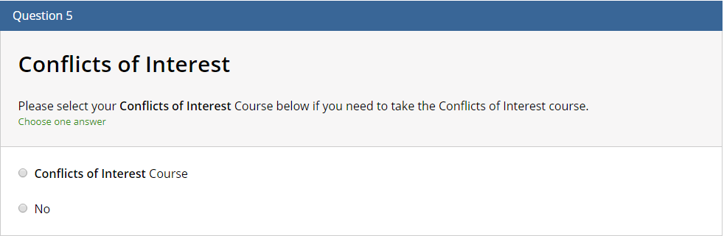

The PHS regulations on Objectivity in Research (revised in August 2011) are designed to promote objectivity by establishing standards that provide a reasonable expectation that the design, conduct and reporting of PHS Research Activities will be free from bias resulting from any Investigator’s Financial Conflicts of Interest. Each institution applying for or receiving research support from PHS must comply with the regulations by putting in place a policy whereby one of the elements is training. SDSU uses the CITI web-based courses to satisfy this requirement. Initial and continuing education (every 3 years) are required. A notice to persons who will be required to complete this training will be sent by Contracting and Compliance. For all others this training is optional.

Conflict of Interest Learner Group:

* Conflict of Interest-Choose this group if you have received a notice of required COI training and are a Principal Investigator or other investigators/key personnel who have or share responsibility for the design, conduct, or reporting of PHS sponsored projects.

Most modules contain a quiz. A minimum aggregate score of 80% is required to pass the courses. You do not need to complete all of the modules in one session. Export Control

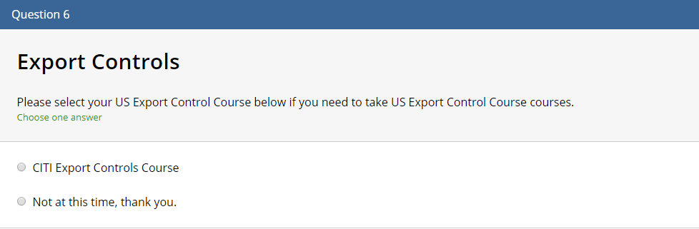

University staff, students and/or employees may be required to fulfill the export control training requirements. The course contains modules providing a basic overview of export controls. Also provided is information specific to the various federal agencies that oversee export controls including the State Department’s International Traffic in Arms Regulations (ITAR), the Commerce Department’s Export Administration Regulations (EAR) and the Treasury Department’s Office of Foreign Assets Control (OFAC). A notice to persons who will be required to complete this training will be sent by the Export Control Officer. For all others this training is optional.

Export Control Learner Group:

* Export Control-Choose this group if you have received a notice of required training.

Most modules contain a quiz. A minimum aggregate score of 80% is required to pass the courses. You do not need to complete all of the modules in one session.